

|  |  |  |
| --- | --- | --- |
| Mathematics Department | |  |
| Course: ATMAA | |
| Topic Title: Growth & Decay in Sequences  Test 1 | |
| Student Name:_____________________________________ | Date: ____________ | | |
| Special Instructions: **Calculator Allowed**  Formula Sheet Allowed | Time Allowed: 45 mins | | |
|  | Marks: / 40 | | |

**Question 1. (1, 2: 3 marks)**

A sequence has a recursive formula given by:

$T_{n+1}=0.6T_{n}, T_{1}=150$

a) Determine the first five terms of the sequence.

b) What percentage increase or decrease occurs with each successive term?

**Question 2. (2, 2:4 marks)**

A new road 85km long is being laid. At the end of Stage 1, 35km of road has been laid.

It took 45 days to complete Stage 1.

For Stage 2, covering the remaining 50km, an extra 600m of new road is completed each day.

Let $t\left(n\right)$ be the length of road completed at the start of day $n$ in Stage 2.

a) Write a recursive equation for the length of completed road at the start of day $n$.

b) Find how long it would take for the entire road to be laid.

**Question 3. (2, 2:4 marks)**

In 2005, a recycling centre processed 2000 tonnes of plastic containers. The amount of plastic containers processed each year, increased by 8% p.a.

Let $a(n)$ be the amount of plastics containers recycled.

a) Write a recursive rule for the amount of plastic containers recycled.

b) In which year will the recycling centre for the first time recycle more than 5000 tonnes of plastic containers?

Assume that the recycling centre is able to handle the growth in the amount of containers recycled.

**Question 4. (4, 2: 6 marks)**

The fifth term of a geometric progression is 81 and the second term is 24.

Find:

a) the fourth term

b) the recursive formula for this sequence

**Question 5. (1, 1, 1, 2: 5 marks)**

A plasma TV costs $12 000 and John decides to borrow the money at a rate of 2.4% per month. He agrees to

repay $400 per month for the life of the loan. The amount owing after $(n+1)$ months is related to the amount owing after $n$ months according to the rule:

$T_{n+1}=1.024T_{n}-400 n≥0$

where $T_{n}$ is the amount owing after $n$ month.

a) Determine $T_{0}$

b) Find the amount owing after the first month

c) Find the amount owing after six months

d) How many months will it take for John to pay out his loan?

**Question 6. (3, 1, 1, 2, 2: 9 marks)**

A large swimming pool contains 80 000 litres of water. Each day 5% of the water is lost due to evaporation.

An additional 2 500 litres of water is added to the pool at the end of each day.

The recurrence relation is: $T_{n+1}=rT_{n}+d, T_{1}=a$

where $T_{n}$ represents the amount of water in the pool at the start of the $n$ th day.

a) Calculate the values of $r, d$ and $a.$

b) How many litres of water will be in the swimming pool at the start of the 6th day?

c) How long will it take for the water in the swimming pool to fall below 60 000 litres?

d) Using the recurrence relation find the steady-state solution of the pool over time.

e) If the amount of water in the pool is not to fall below 65 000 litres on any given day, find the amount of water that needs to be added at the end of each day.

**Question 7. (3, 1, 1, 2, 2: 9 marks)**

Consider the sequences A, B and C defined by the recurrence relations.

A: $a_{n+1}= a_{n}+3, a_{0}=1$

B: $b_{n+1}= {2b}_{n}, b_{0}=1$

C: $c_{n+1}= {2c}_{n}+3, c_{0}=1$

a) List the first six terms of each of the above sequences.

b) On the axes below, plot the terms of each of the given sequences with respect to $n.$

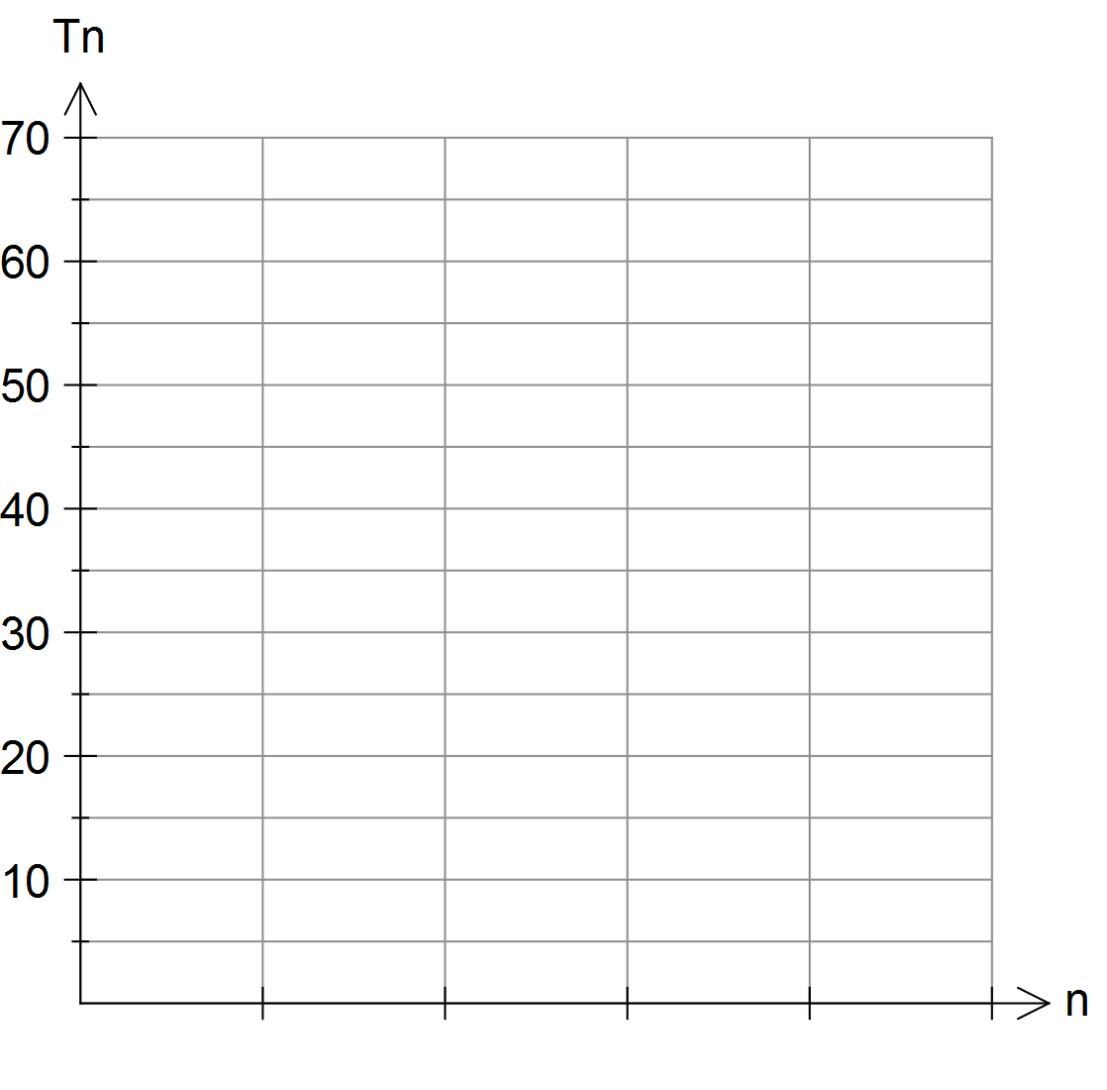

c) Comment on the shape of each of these recurrence relations.

d) Discuss the rate of growth between the terms in each of the given sequences.